

January 2026 Newsflash

2025 Fundraising
Every survivor has a story. When you donate to INSPIRE!africa, you become part of their story and help to give them the opportunity to write it themselves instead of having it written for them. With your donations, their next chapter includes healing and moving forward.
We are thrilled to announce that in 2025 we raised $64,000 at our fundraiser in November! With the final installment of $46,000 from the bequeath we received in 2023, this year we will send $110,000 to Rwanda for projects supporting survivors. For information on the bequeath, please see our March 2024 newsletter. On behalf of our Rwandan friends, thank you so much for all your support!

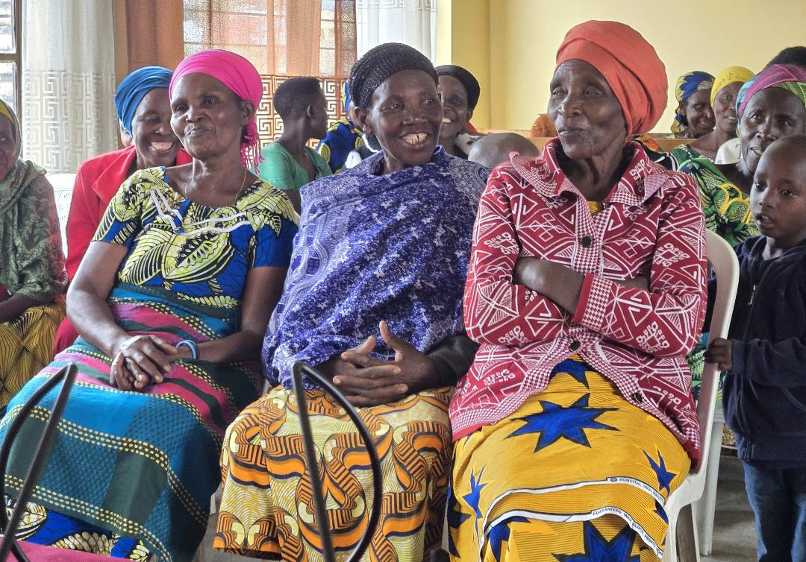

2025 Tax Receipts
Thank you again to all of you who donated to INSPIRE!africa in 2025. Your tax receipt will be sent by email in February and will come from cowiejae@gmail.com. Please be sure to check your junk folder if you don't receive it.

Follow INSPIRE!africa on social media!
Facebook: INSPIRE!africa
X (formerly known as Twitter): @INSPIREafrica2
Website: INSPIRE!africa

