

March 2026 Newsflash

Survivors Fund’s (SURF) Executive Director is coming to Calgary!
We are delighted to announce that Sam Munderere, Executive Director of our Rwanda partner SURF will be visiting us in Calgary during the week of April 13. Those of you who have been to Rwanda with us will remember Sam well. For those who have not been with us in Rwanda yet, this is a great opportunity to meet him. We have a few opportunities for you to see Sam and hear his news from Rwanda. Please see below and check our website and Facebook page for more details.
Thursday April 16: Pub night with Sam to enjoy an informal evening of stories and conversation.
When: 7:00-9:00 pm
Please register here before April 12 so we can book a venue that is the right size. The event is free. Food and drinks will be available for purchase.
Saturday, April 18: Commemoration of the Genocide against the Tutsi in Rwanda
When: 3:00-6:00 pm
Where: Mount Royal University
Please see below for more details.
Sunday, April 19: Sam will provide a reflection at the Hillhurst United Church worship services.
When: 9:00 am and 10:45 am
Where: Hillhurst United Church, 1227 Kensington Close NW
A meet and greet along with a light lunch will follow after the 10:45 service.

Calgary Commemoration of the 32nd Anniversary of the Genocide Against the Tutsi in Rwanda
The guest speaker for this year’s Commemoration will be Sam Munderere. He will be speaking on the topic of The Evolving Journey of Survivors of the Genocide against the Tutsi, 32 Years Later. As SURF is our partner in Rwanda, we are pleased to join the Calgary Rwandan community for this important event.
When: Saturday, April 18 3:00-6:00 pm
Where: Ross Glen Hall, Mount Royal University 4825 Mt Royal Gate SW



A Word From One of Our Volunteers
In 2014, I told a colleague that I was going to the INSPIRE!africa fundraiser. He asked why, 20 years after the genocide, Rwandans still need help. I didn’t really have an answer.
Four years later, in 2018, I went to Rwanda with INSPIRE!africa. I met people whose lives were devastated by the genocide. There was a group of four young people who were children during the genocide. They stayed together and became a family, living on the streets, after their families were killed. I also met a young woman who was just a child during the genocide and whose property had been stolen by a family member after her parents were killed.
What I saw was the life-changing impact the projects INSPIRE!africa have made on real people. The group of children who stayed together have been able to remain together. One had his property returned to him thanks to the Helpline, and SURF built a house for each of them on the property. They knew that your donations to INSPIRE!africa helped to make that happen, and to say thank you they sang ‘You Are My Sunshine’ for us. It was beautiful.
Again thanks to the Helpline, the young woman has her property back. When we were in Rwanda, she was almost finished studying finance and had done driver training. She now has a license to drive a 5 ton truck!
I have that answer now. Yes, it is about the trauma that they and their families have faced, but most of all, they are survivors, and they deserve to thrive. You can help them to thrive. You can change their lives.
-Heather Knorr

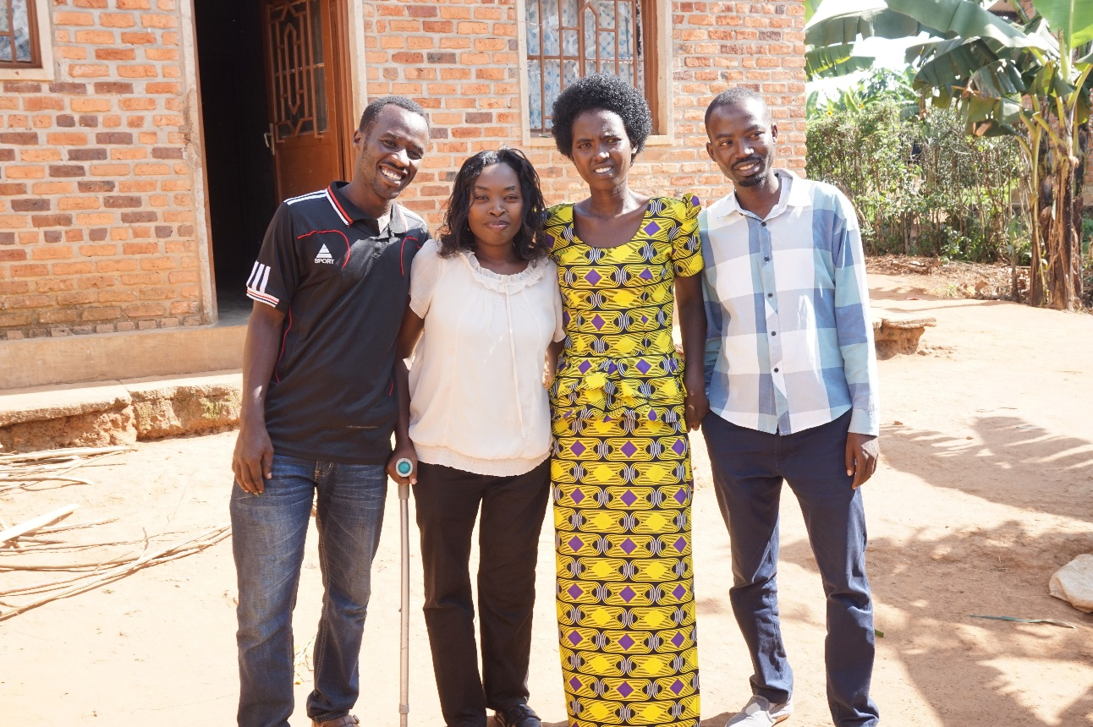

News From Our Board
After 10 years as our faithful treasurer, Jae Cowie will be stepping down. We are incredibly grateful for all the work he has done to ensure you receive your tax receipts, our tax return is filed, bank transfers are sent successfully to our Rwanda partners, and your donations are gratefully received at our fundraisers.
In addition, as a valuable member of the Board, Jae has helped to guide us in the decisions we make to be an accountable organization focused on the needs of Rwanda’s survivors. We were pleased that Jae was able to join us on our volunteer trip to Rwanda in 2018, and are happy that he has offered to continue volunteering at our November fundraiser. Thank you Jae, we wish you all the best.
Thankfully, we didn’t need to look far for another treasurer, as Diane Altwasser has offered to take on this role. Diane has been on the INSPIRE!africa Board for 13 years, has participated in 4 volunteer trips to Rwanda with us, has a financial background, and held operations and financial positions in the not-for-profit sector before she retired in 2024. Thank you, Diane!
Tax receipts
Tax receipts for 2025 were sent at the end of February. If you haven’t received yours, please contact Jae at jaecowie@yahoo.ca.

Follow INSPIRE!africa on social media!
Facebook: INSPIRE!africa
X (formerly known as Twitter): @INSPIREafrica2
Website: INSPIRE!africa

