
JUNE 2026 NEWSFLASH
Survivors Fund’s CEO Visits Calgary
From April 14 to 19, INSPIRE!africa had the pleasure of hosting Sam Munderere, CEO of our Rwanda partner organization Survivors Fund (SURF), in Calgary. This was Sam’s first trip to Western Canada, so we made sure he saw as much as possible during his short visit. We took him on a day trip to Banff and Lake Louise in the Rocky Mountains. The highlight there for him was taking the gondola up to the top of the Lake Louise Ski Resort to see the spectacular views, have a snowball fight, and see the skiers enjoying all the snow. In Calgary, he saw quite a bit of the city, including some 1988 Olympic venues, a tour of downtown, and an evening with some INSPIRE!africa volunteers in a local pub. Unexpectedly, he also had the experience of a spring snowstorm with around 20 cm of snow – the most he had ever seen! - and cold temperatures that required a winter jacket and snow boots! And in true Calgary fashion, he also had the experience of seeing it melt almost as fast as it came.

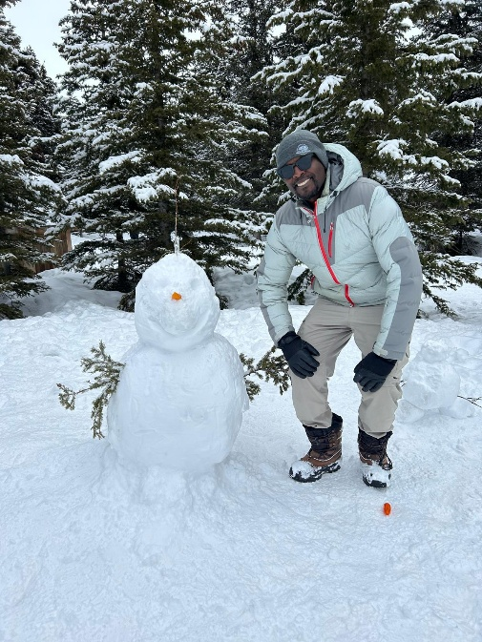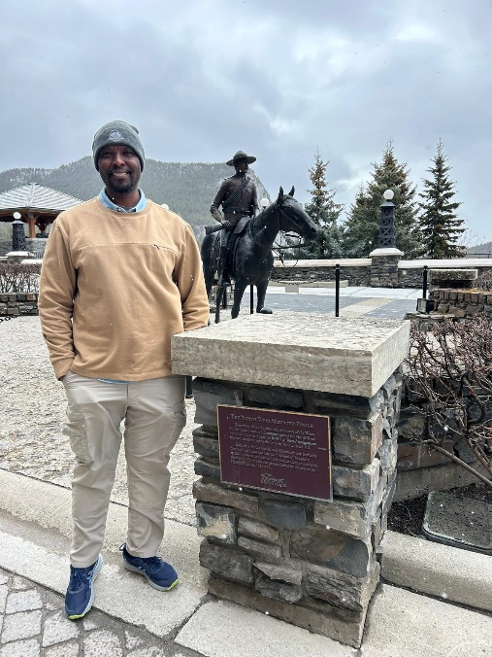

The main purpose of his visit was to build relationships, share updates on the Rwanda projects we support, and for us to hear his thoughtful reflections on the inspiring work he does.

One of his speaking engagements was at the Sunday services at Hillhurst United Church where he and Anne Kleffner, an INSPIRE!africa volunteer and 2008 Rwanda trip participant, engaged in an interesting conversation about the challenges he had when starting to work with Rwanda’s survivors and what sustains him now to carry on with the work he leads in Rwanda. The interview can be viewed at this Link, starting at minute 35.

The 32nd Commemoration of the Genocide Against the Tutsi in Rwanda
Sam was also a keynote speaker at the annual Commemoration of the Genocide Against the Tutsi in Rwanda that was hosted by the Rwandan Canadian Society in Calgary. The event was well attended with over 300 guests, and Sam provided some insightful observations from the work he has done with survivors over the past 22 years. Here are some excerpts from his remarks.

How are survivors doing, 32 years after the genocide?
“For many, the past is not behind them. It lives in the present. It shapes the way they experience the world, the way they relate to others, and the way they move through each day. It appears in moments that seem ordinary to others—a sound, a smell, a silence, a date on a calendar. It is both a lifetime and, at the same time, something that feels as immediate as yesterday.”
“Survival is a continuous journey. It unfolds every day, in ways that are often invisible to the outside world. It is in the quiet decisions people make—to wake up, to engage, to participate in life, even when the weight of the past remains. It is in the effort it takes to maintain relationships, to raise children, to go to work, to contribute to society. These are not small things. They are acts of strength that often go unrecognized.”
How is Rwanda doing?
“Rwanda’s progress is not accidental. It is intentional. It is built through deliberate effort—through policy, through leadership, and most importantly, through the daily choices of individuals who refuse to let destruction define their future.”
“It is built by survivors who wake up each day and choose to continue. It is built by individuals who, despite loss, choose to rebuild their lives. It is built by families who choose to reconnect, even when trust has been broken. It is built by communities that choose unity over division. It is also supported by leadership that commits to rebuilding a nation grounded in dignity, accountability, and shared identity.”
What is our Call to Action?
“We must reject hate, challenge denial, support justice, and build communities rooted in dignity. Indifference is not neutral. It allows harm to grow. Silence can be dangerous.”
Sam’s full speech is available on our website.
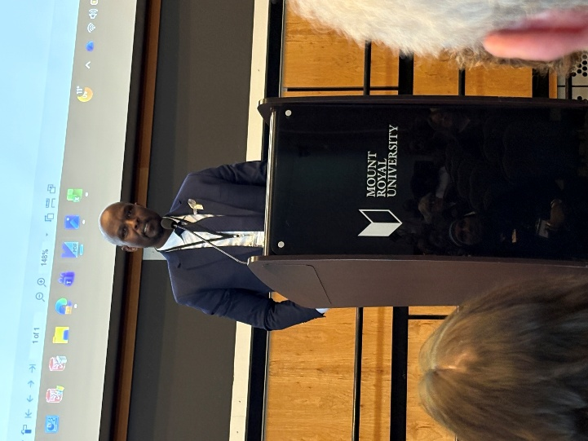
Sam Munderere, CEO of Survivors Fund (SURF)

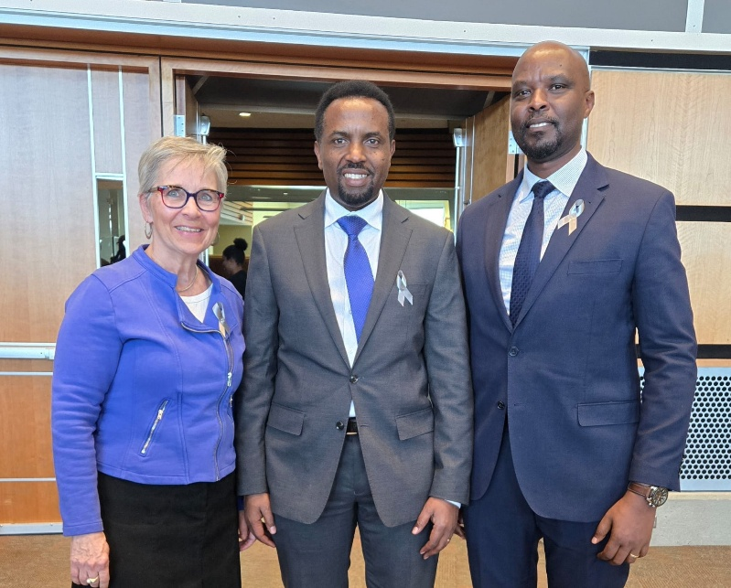
L to R: Margaret McQuiston, co-Founder of INSPIRE!africa, Jean-Claude Munyezamu, President of the Rwandan Canadian Society in Calgary and Sam Munderere
2026 Fundraiser - Save The Date!
In November we will have our annual family friendly Rwandan Tea and Coffee House fundraiser. Please plan to join us. Stay tuned for more information in future newsletters!

Date: Saturday, November 14
Time: 1:00-4:00 pm
Location: Scarboro Community Association: 1737 14 Ave SW, Calgary (Free parking behind the tennis courts)
Follow INSPIRE!africa on social media!
Facebook: INSPIRE!africa
X (Formerly known as Twitter): @INSPIREafrica2

