SEPTEMBER, 2023 NEWSFLASH
2023 November Fundraiser – In Person!
We are excited to announce that INSPIRE!africa is holding its annual fundraiser supporting projects in Rwanda on November 18 from 1:00 to 4:00 pm at the Scarboro Community Hall. This is our first in person event since 2019 and we are excited to have an opportunity to connect with all of you again!

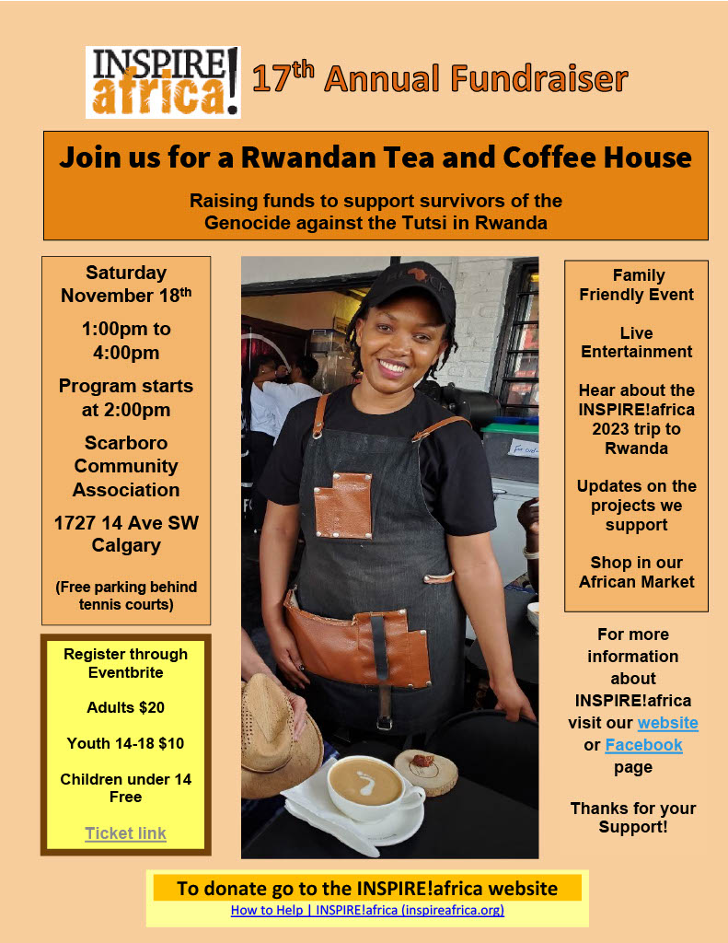

As always, in addition to a great program, you will have the opportunity to see – and purchase! - the great selection of fabulous crafts that our volunteers brought back from Rwanda this year. These handmade crafts were procured from community projects in Rwanda and make fantastic holiday gifts!

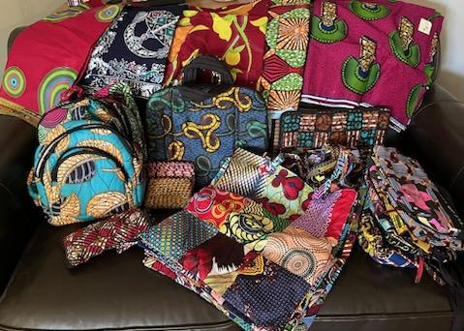

We can’t wait to see you again!

How the Helpline Is Changing Lives
So many survivors have had their lives turned around for the better thanks to the Helpline. It provides legal support to reclaim family property and trauma counselling if needed. In Rwanda this spring, we had the opportunity to meet a couple of beneficiaries of the Helpline which INSPIRE!africa supports.
Meet Speciosa: Speciosa was born into a family of five and although she survived the genocide, her father and brother did not, nor did their family home. Without a home, she was forced to move from house to house, living off the generosity of others. She soon tired of that and decided the only way to create some stability in her life was to get married. However, this hasty decision led her to marry an abusive man. She tolerated the relationship for many years but eventually, she found the courage to leave with her three young children. The years of abuse, along with her untreated trauma from the genocide and the weight of raising three children on her own led her into a deep depression. She was not sleeping, not eating, had constant headaches and had given up on life. Fortunately, someone told her about the Helpline. When she called, the counsellor on the other end of the phone line was Donatha. Donatha became like a mother to Speciosa, providing her with emotional support, arranging for the medical care she needed as well as tuition for her children to attend school. When we met her this past spring, Speciosa was one of the happiest people we met in Rwanda. She was so grateful for Donatha who had literally saved her life.

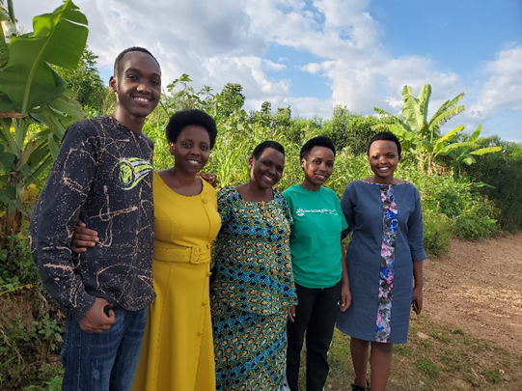
Meet Chantale: Chantale was only 5 years old at the time of the genocide. During the genocide she lost her whole family except for her older sister. A neighbour stepped in to care for the two sisters and took them from Kigali to the Congo where they would be safe. During that trip, Chantale got separated from the others and spent years in the Congo on her own. Eventually she made it back to Kigali but it took a long time for her to figure out where exactly she was from. Since she was so young when she left, she could only remember the name of her sister and the neighbour. When she eventually made it back to her community, she learned that her sister had died but before she passed, she had been tricked into selling the family property for a fraction of what it was worth. Chantale found out about the Helpline and called them. Jean Damesean, the lawyer supporting the Helpline, was able to help but it took considerable work since Chantale did not know the names of her parents or any other details about them or the land. Thanks to his efforts, Chantale will soon have the title to the family land. She will then be able to earn a living by farming it. She is contemplating selling a portion of it so she has the money to start a small business.
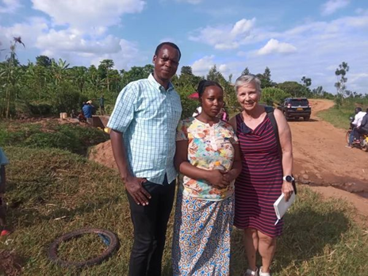
As you can see, your support of the Helpline is truly changing lives. On behalf of survivors, THANK YOU!
To Donate go to the INSPIRE!africa website:
How to Help | INSPIRE!africa (inspireafrica.org)

Follow INSPIRE!africa on social media!
Facebook: INSPIRE!africa
X (formerly known as Twitter): @INSPIREafrica2

